UNIT 5
Lesson 4 – LET'S PARTY

* Uputa za učitelja:
U zadatcima slušanja učenik sluša rečenicu po rečenicu i
nakon svake slijedi zaokruživanje.

1 a) Look at the pictures. What can you see?
Where are the people? What are they doing?
How are they feeling? Talk to your classmate.
Pogledaj slike. Što vidiš na njima? Gdje su ljudi?
Što rade? Kako se osjećaju?

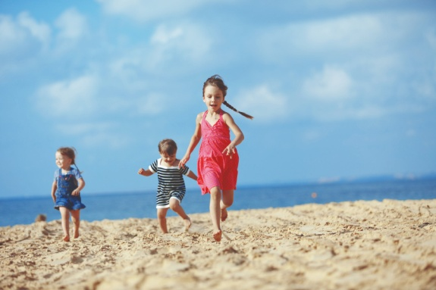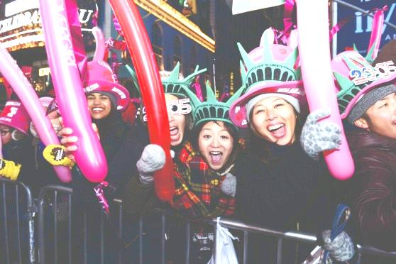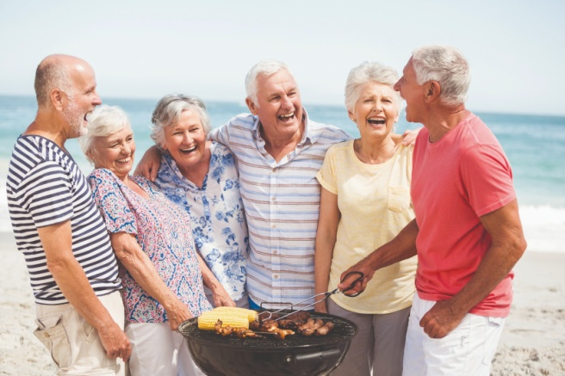

b) Have you heard about these places? What are they?
Where in the world are they? Talk to your teacher.
Jesi li čuo za ova mjesta? Što su ta mjesta? Gdje se na svijetu
nalaze ta mjesta? Razgovaraj sa svojim učiteljem / učiteljicom.

Rab Zagreb Australia Zadar New York
UK USA Croatia

c) Tim is talking about different events in different parts of
the world. Listen to an interview with Tim track 5.4.
Which places is he talking about? 
Circle the places you hear.
Tim pričao o različitim događajima koji se zbivaju na različitim mjestima.
Poslušaj intervju s Timom. Zaokruži mjesta koja spominje.

Rab Zagreb Australia Zadar New York
UK USA Croatia

d) Listen, point and say. Poslušaj, pokaži i ponovi.

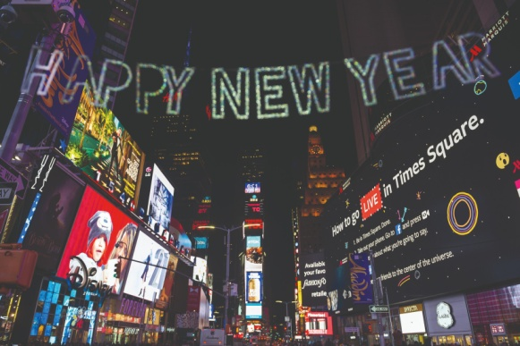
A new Year's Eve party
Proslava Nove godine

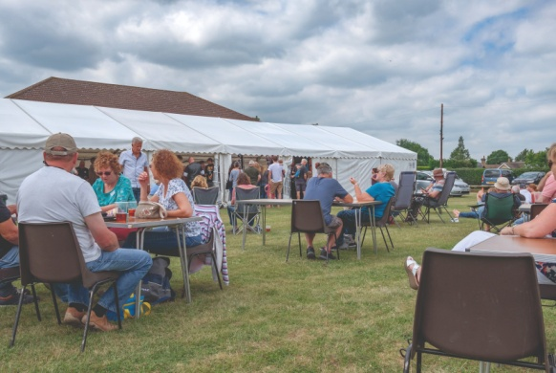
Village festival
Seoski festival
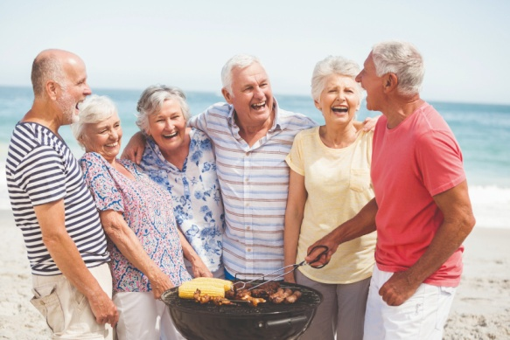
Beach party
Zabava na plaži

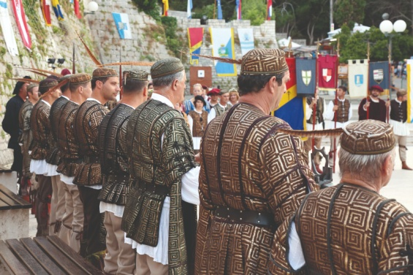
A traditional medieval festival
Tradicionalni srednjovjekovni festival

e) Listen to an interview with Tim – track 5.4.

Which events is he talking about? Circle the words you hear.
Poslušaj intervju s Timom. Zaokruži sve događaje koje spominje.

Halloween party A New Year’s Eve party Village festival
Beach party Kid's festival A traditional festival

f) Match the events to the places.
Spoji događaje i mjesta gdje se oni zbivaju.

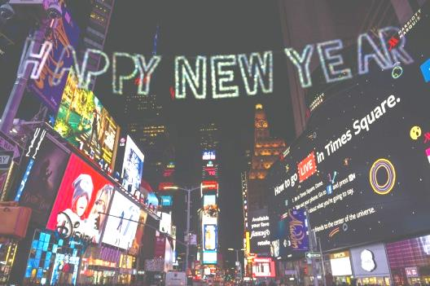
1 A New Year’s Eve party ___ on the Island of Rab.
Proslava Nove godine na otoku Rabu.

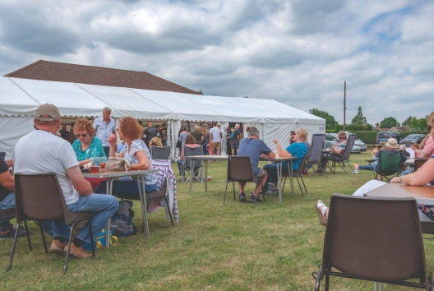
2 Village festivals ___ in Australia.
Seoski festivali u Australiji.
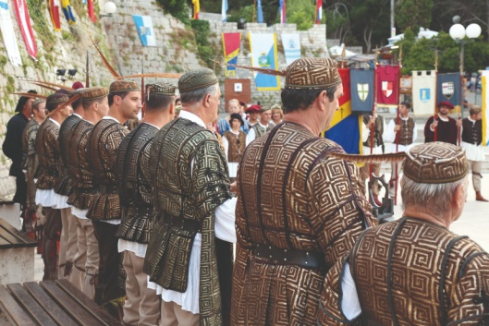
3 A traditional medieval festival ___ in the UK.

Tradicionalni srednjovjekovni festival u Ujedinjenom Kraljevstvu.

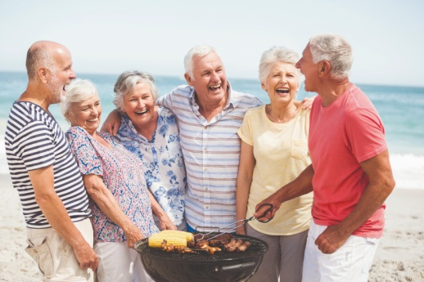
4 Beach parties ___ in Times Square
Zabave na plaži in New York.
na glavnom trgu
Times Square u New Yorku.

- 2 a) Listen to your teacher read the text.
Cross out X the wrong expression in purple.
Poslušaj svog učitelja kako čita tekst. Prekriži netočan izraz.

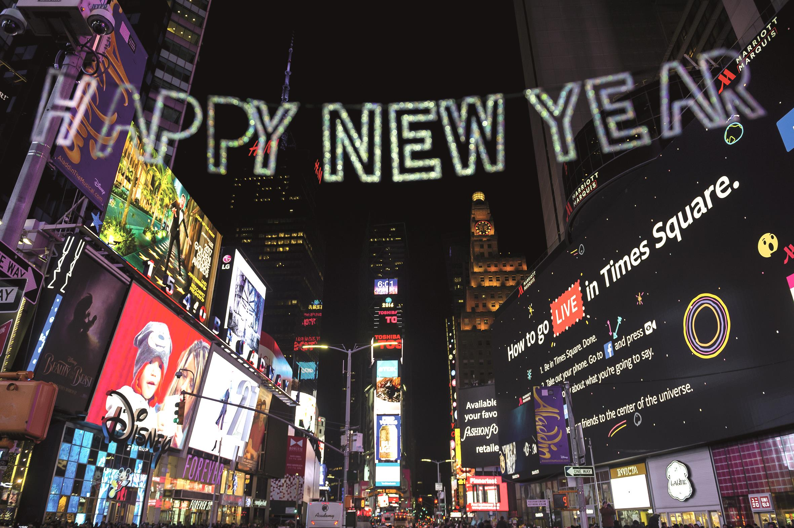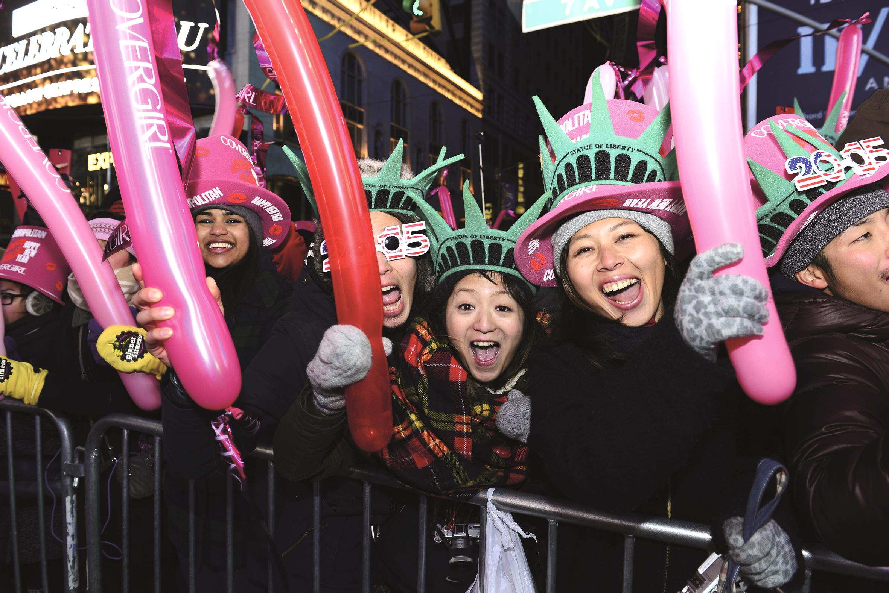

A New Year’s Eve party in New York.
Novogodišnja zabava u New Yorku.

Tourists from all over the world
Turisti iz cijeloga svijeta

are celebrating / are playing New Year in Times Square.
slave / igraju Novu godinu na glavnom trgu Times Square u New Yorku.

They are dancing and singing.
Oni plešu i pjevaju.
They are taking selfies.

b) Copy the correct sentence for the text.
Prepiši točnu rečenicu iz teksta. Fotografiraju sami sebe.

Tourists _________________________________________

_________________________________________________ .

- 3 a) Listen to your teacher read the text.
Cross X out the wrong expression in purple.
Poslušaj svog učitelja kako čita tekst. Prekriži netočan izraz.
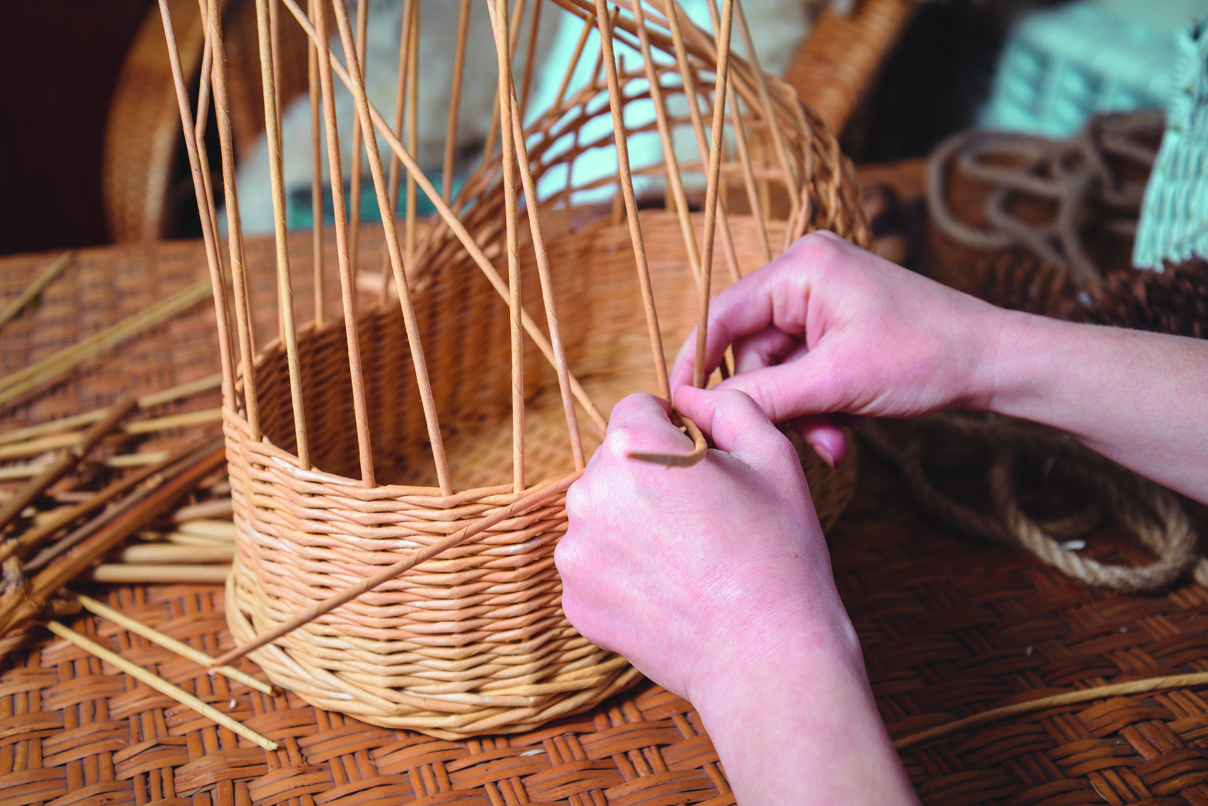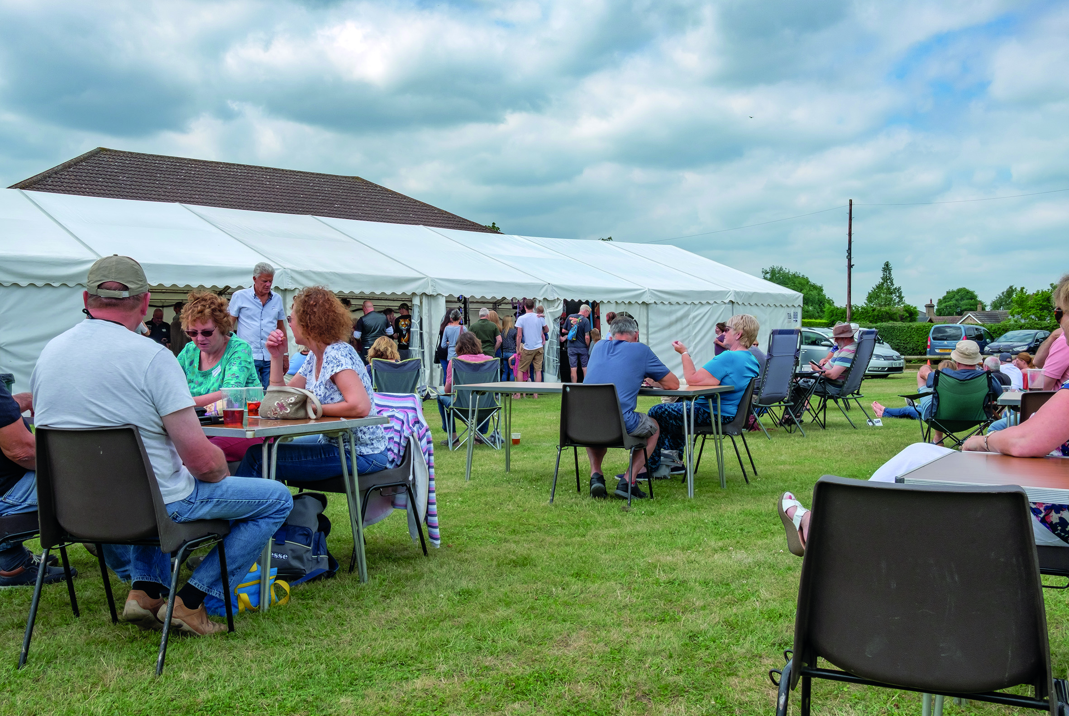

Village festivals in the UK.
Seoski festivali u Ujedinjenom Kraljevstvu.

The villagers are playing / are singing old games
Ljudi sa sela igraju / pjevaju stare igre

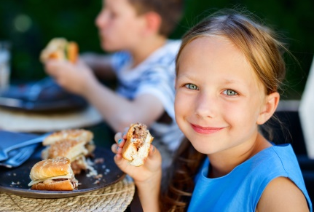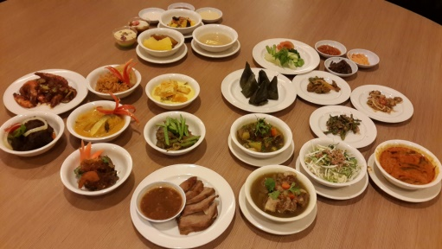
and tasting traditional food.
i kušaju tradicionalnu hranu.

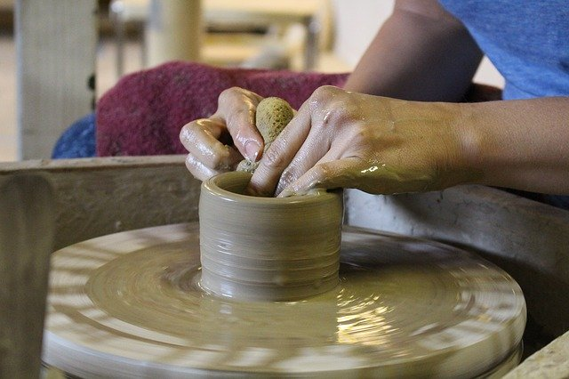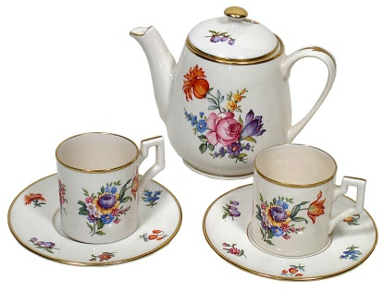
Craftsmen are making traditional souvenirs
Obrtnici izrađuju tradicionalne suvenire.

b) Copy the correct sentence for the text.
Prepiši točnu rečenicu iz teksta.

The villagers __________________________________
____________________________________________
- 4 a) Listen to your teacher read the text.
Cross out X the wrong expression in purple.
Poslušaj svog učitelja kako čita tekst. Prekriži netočan izraz.

Beach parties in Australia.
Zabave na plaži u Australiji.

A dog is surfing / is eating. 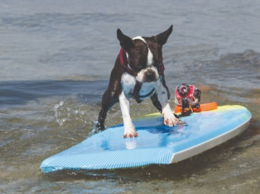
Pas surfa na valovima.
Some kids are playing games. 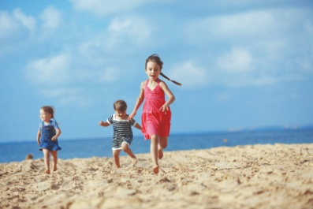

Neka djeca igraju igre.

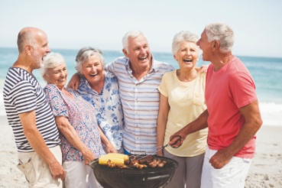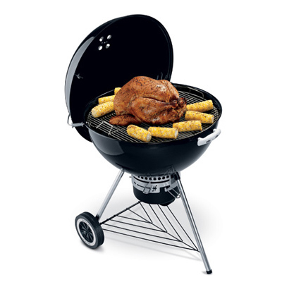
The neighbours are surfing / are having a barbecue on the beach.
Susjedi surfaju na valovima / imaju roštilj na plaži.

b) Copy the correct sentences for the text.
Prepiši točne rečenice iz teksta.

1 A dog __________________________________ .
2 Some kids are playing games and the neighbours
_________________________________________________ .

- 5 a) Listen to your teacher read the text.
Cross out X the wrong expression in purple.
Poslušaj svog učitelja kako čita tekst. Prekriži netočan izraz.

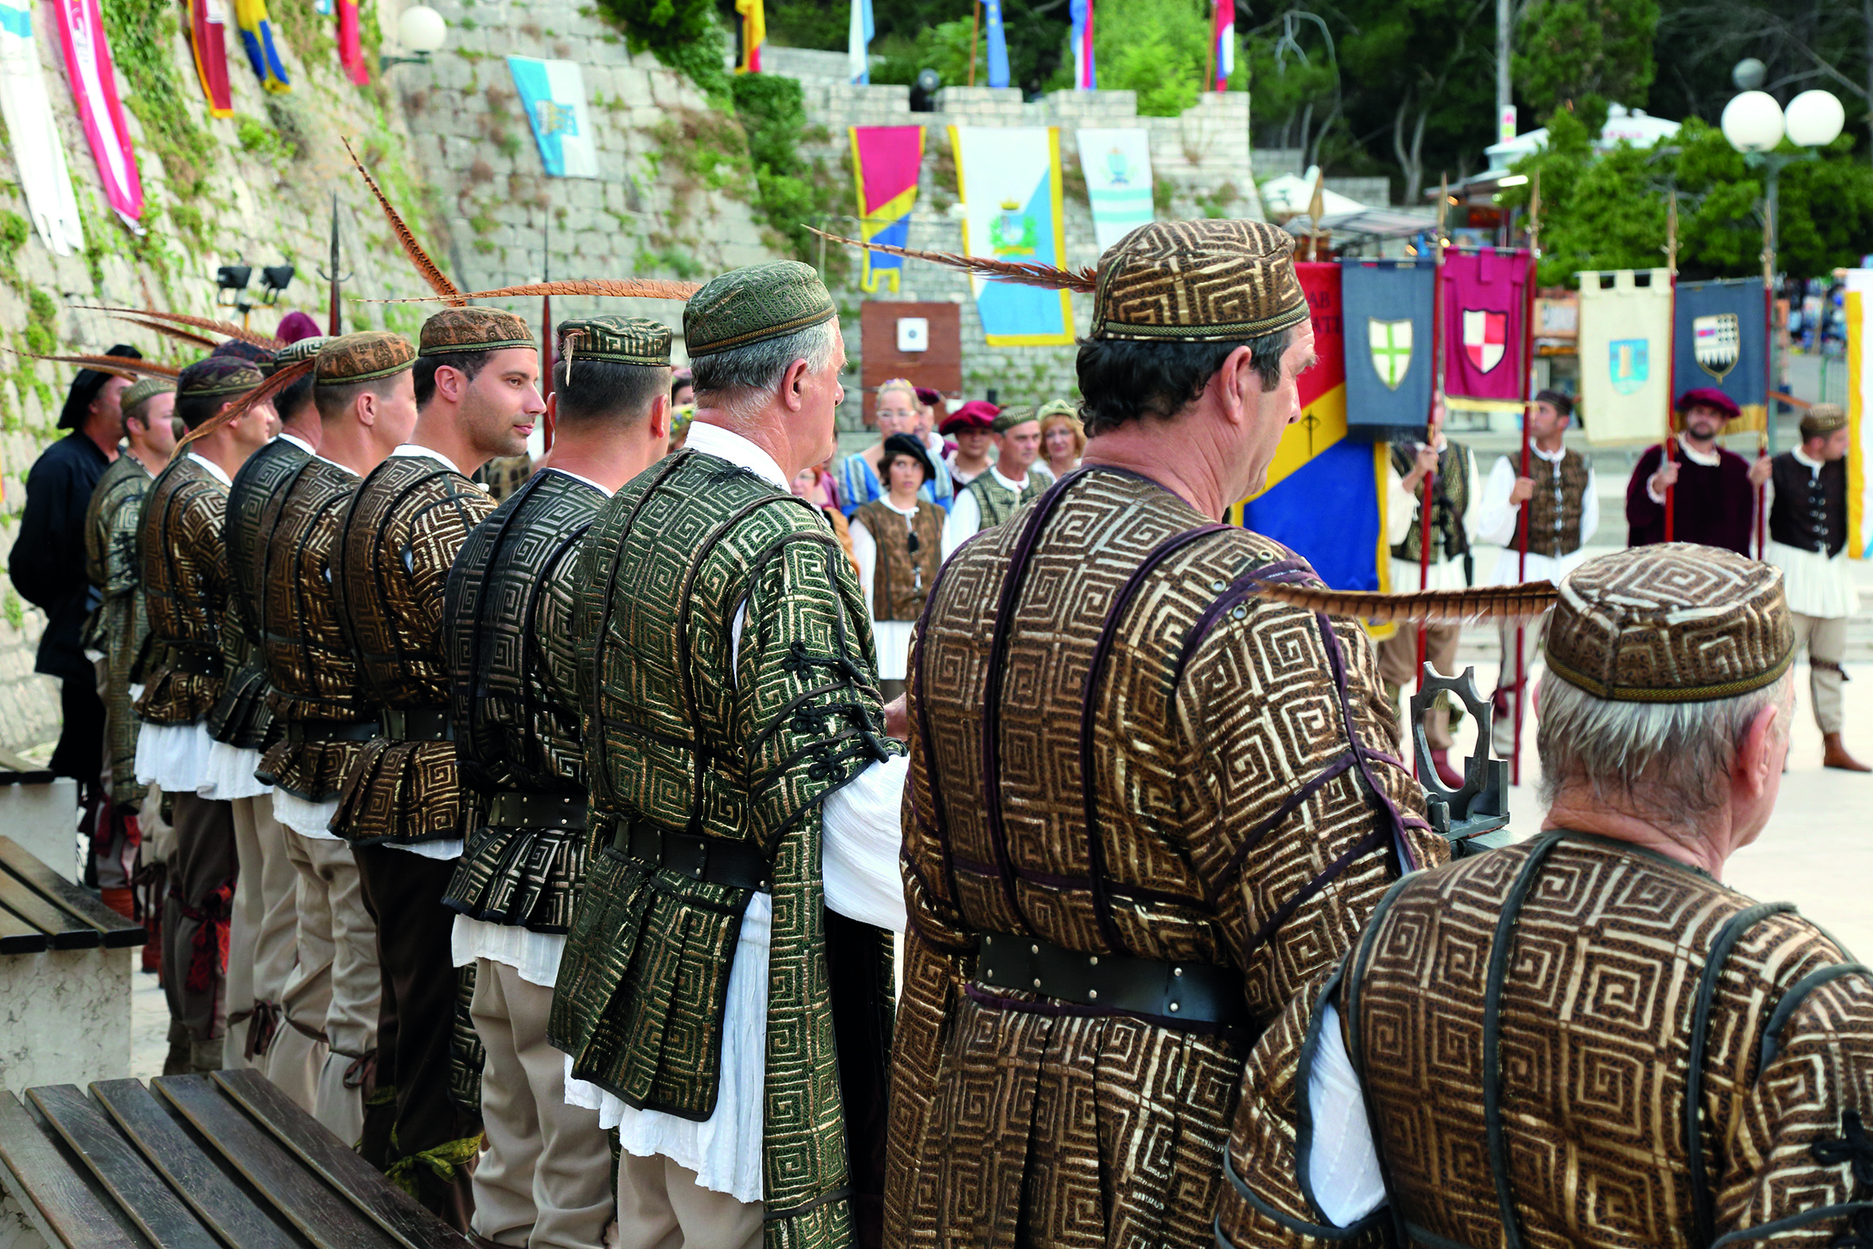

A traditional medieval festival on the island of Rab.
Tradicionalan srednjovjekovni festival na Rabu.

These men are wearing / are dancing traditional costumes.
Ovi mladići nose / plešu tradicionalne kostime ( odjeću).

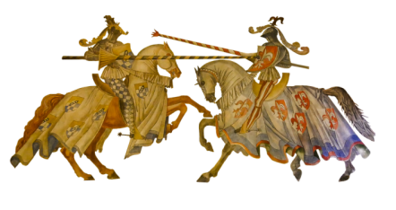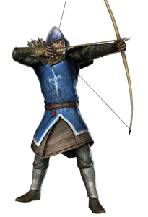

They are taking part in a tournament.
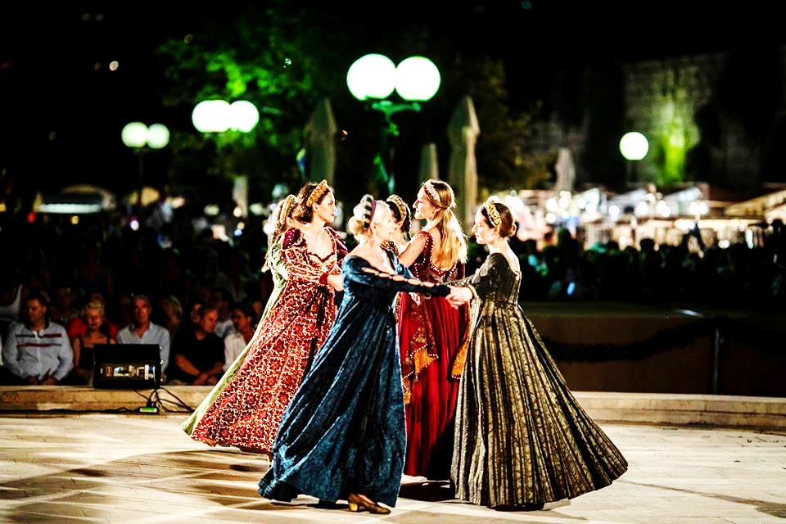
Oni sudjeluju u viteškoj borbi.

Everybody is having fun.
Svi se zabavljaju,a dame jedu / plešu.
The ladies are eating / are dancing.

b) Copy the correct sentence for the text.
Prepiši točnu rečenicu iz teksta.
Everybody is having fun and the ladies ________________ _________________________________________________ .

Project (Projekt)
Step 1: Go online! Search the world festivals.
Potraži na Interenetu o svjetskim festivalima.
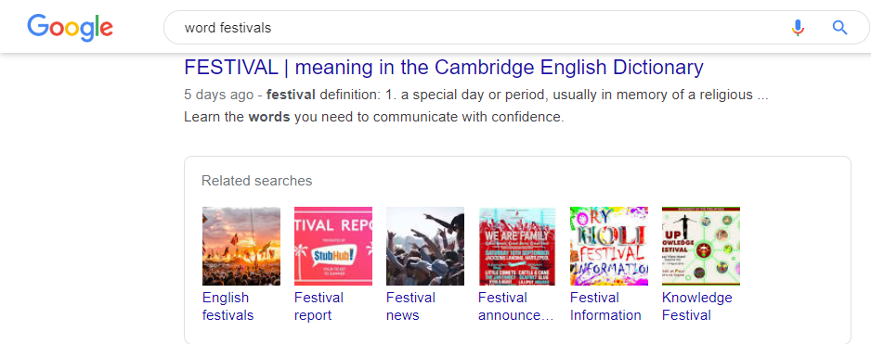

Step 2: Pick one interesting event.
What is the name of the festival you chose?
Izberi jedan zanimljiv događaj. Koji si festival odabrao?

Step 3: Find information about an interesting street festival.
What is interesting about this festival?
Pronađi zanimljive informacije o festivalu.
Što je zanimljivo u festivalu?

Step 4: Choose 5 pictures. Print them.
Izaberi slike. Isprintaj ih.

Step 5: Create a fact sheet including these information:
What is the name of the festival?
Where does it take place?
What is going on (activities)?
Include the printed pictures.
Napravi jedan letak s informacijama o zanimljivom festivalu kojeg si
odabrao / odabrala. Uključi informacije koje odgovaraju na pitanja:
Koje je ime festivala? Gdje se održava festival?
Koje su aktivnosti za vrijeme festivala?
Uključi isprintane slike festivala.

FESTIVAL FACT SHEET

1 What is the name of the festival? (Koje je ime festiavala?)

__________________________________________________________

2 Where does the festivale take place?
(Gdje se održava festival?)

__________________________________________________________

3 What activities are there in for the visitors?
( Što se radi tijekom festivala? / Koje se aktivnosti provode tijekom festivala?)

__________________________________________________________
__________________________________________________________________________________________________________________________________________________________________________________________________________________________________________________________________________________________________
4 Slike ( nalijepi isprintane slike):

